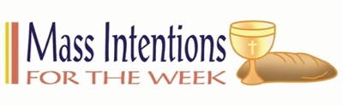
Monday: 21 February 2022
9:30am Maxie Pereira

Tuesday: 22 February 2022
9:30am In honour of St. Rita
Special Blessing for Domenico
Yanus Chura
Maria Raquel Miranda Marroquin

Wednesday: 23 February 2022
9:30am Matthew Dishart
Luigi Palumbo,
Vito Piacente
Ben Leonetti

Thursday: 24 February 2022
9:30am

Friday: 25 February 2022
9:30pm A. J. Mathew, Graciano Maglian &
Fiore Cimicata.
Thanksgiving Mass for Matthew, Natasha,
Ariana, Dorian Cimicata and families Susie
Cimicata. The living and deceased members of
the Cimicata and Howard families.
Anthony, Yvonne and Gideon De Sousa and
families.
Dominic & Babu Daniel

Saturday: 26 February 2022
9:30am Allessandro De Zorzi

5:30pm George Lazarus
Josepeh Fernandez
Antonio Armiento

Sunday: 27February 2022
7:45am

9:00am

10:30am Parishioners of Transfiguration Church
Giovanni Mazzanti
Kevin Valentine Fernandes
Ndrek Dema

12:00pm Patricia Paolini & Neil Paolini

7:00pm

JOIN OUR YOUNG ADULTS GROUP
Calling all young adults interested in
building community with other one another and growing in faith. Our young adult group meets every other Monday evening. This is a great opportunity to meet other young adults within the parish. If you are interested in joining, please email us at transchurch45@gmail.com with your name and phone number.

PRAY FOR THE SICK
Theresa Burns, Sonja Schryer,
Noemy Pereira, Clint Viegas,
Samuel Cordeiro, Arthur Ruston,
Avio Carboni, Raphael Colaco,
Dana McGrath, Roman Joe Zakrajse,
Enzo, Domenica, Teresa Pirrello,
Margaret Speciale, Karen Radeczy,
Joe Simardone, Margaret Ramjattan

PRAY FOR THE DEPARTED SOUL
May the soul of the faithful departed rest in peace:
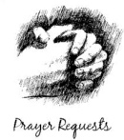
Fr. Vito Marziliano
Krystyna & Wojciech Lopaczyk

BECOME A MEMBER OF THE PARISH
Often people may attend Mass at a certain parish for several years but never register. When a pastor accepts the registration, he also accepts the responsibility of their spiritual care. Registering in a parish is a declaration of your desire to be part of a Catholic community and to make a commitment to the life of Transfiguration of Our Lord Parish community.
You may register by completing a parish registration form found on our website and returning it to the Parish Office via email or in person.

COMMUNION AND CONFIRMATION
Sacramental preparation for our communion and confirmation students has started online! By seeking the sacraments, you take a very important step forward with your own religious education. The Sacraments were instituted by Jesus Christ Himself as the primary means to receive his grace. The Sacraments give life to the soul. Let us pray for those receiving their sacraments this year at Transfiguration of Our Lord Church

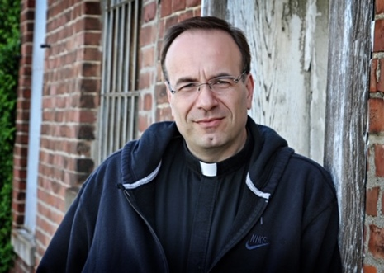
PARISH MISSION
60 MINUTES FOR JESUS
WITH FR. JAMES SICHKO

Join us on February 21, 22 & 23, 2022 at 7:00pm in our church and hear Fr. Jim use real life experiences and ties those experiences into Gospel message of Jesus Christ. Known for his presentations entitled “60 Minutes for Jesus”, each talk is geared for all in a family household with no exceptions. Fr. Jim is a full-time preacher, evangelist and motivational speaker based in the Diocese of Lexington, Kentucky. In February of 2016, Pope Francis commissioned Fr. Jim as one of his Papal Missionaries of Mercy, of which there are only 1000 in the world, 100 in the United States. Before he became a priest, he has made headlines for random acts of generosity and kindness giving away thousands of dollars to people at the grocery store and on the street. He also has had the opportunity to meet and work with many celebrities and was honored by the U.S. Congress for his work.

Due to social distancing measures, the church capacity for this year’s mission is 175 people. Seating will be available in the church hall once we have reached our capacity. The mission will also be available via livestream, please access the link from our website directly at www.transchurch.ca

To cover the cost of the Parish Mission donation envelopes are available in the vestibule/the lobby of the church, and at the exits of the church. Thank you in advanced for your generous contribution, this mission would not be made possible without your support.

SACRAMENT OF MARRIAGE
The sacrament of marriage is a viable sign of God’s love for the church. When a man and a woman are married in the Church, they receive the grace needed for a lifelong bond of unity. As a partnership, it is a union of equals who come together to form a new family. If you are entering into the sacrament of marriage, please contact the office one year in advanced to prepare for this sacrament.

THE OUTREACH PROGRAM
The Outreach program will be collecting men’s new underwear, socks, jeans warm gloves, winter hats & scarves, towels, men’s deodorant, toothpaste, toothbrushes, body lotion, bar soap/body wash, shampoo, razors, shaving cream, Advil, Ensure/Boost, canned food, coffee, tea, rice, vitamins, Vicks Vap-rub, &Neo Citran. *Call Ahead to schedule an appointment

VISIT OUR WEBSITE
Our website is always updated with the latest information regarding upcoming events, sacraments, and parish news. If you would like to stay informed and current, please access the link from our website directly, www.transchurch.ca

CATHOLIC WOMEN’S LEAGUE
A sincere thank you to the Members of the Catholic Women's League and all the Parishioners who supported our Winter Warmth Drive. Thanks to your generosity over 300 items were collected & many are being kept warm with the beautiful hats, mitts, scarves & socks so kindly donated by you. Men's items were sent to The Good Shepherd Shelter. Women's & children's to the Ernestine's Shelter. Thank you again for all the beautiful donations.

FORMED” AVAILABLE AT OUR CHURCH
FORMED is a web-based digital platform, designed to help adults to grow in their faith and in their lives. FREE to all parishioners & your families.
Register at FORMED.org
Already have a account? Want to create a new account?
* Visit FORMED.org * Visit FORMED.org
* Click Sign In * Click Sign In
* Enter your email * Select I Belong to Parish
* Click the link in your email * Find your parish by name
* You’re in! * Enter your email
No password is required

